**APIs Specifications and Design**

**Card2Use**

Website: [www.](http://www.creditkaam.com)Card2Use.com

Mobile App: Card2Use

This document provides: requirements, design, and development of the Card2Use APIs

**Executive Summary** **3**

Business Problems 3

Solution 3

**Architecture** **3**

Web and Mobile App Architecture (with Google Cloud, may change if AWS) 3

APIs Architecture 4

**APIs Specifications** **4**

APIs Framework/Tools 5

Things to consider 5

Authentication API 5

Edge Infrastructure APIs 6

Edge Devices Config APIs (IoT Controller) 6

Edge Sensors Data APIs 7

Card2Use Monitor (Admin Usage, to be used by Card2Use internal) 7

Data Analysis APIs 8

Microservices APIs 8

Users APIs 8

**Microservices Specifications** **9**

**Design** **10**

**Development and Testing Strategy** **10**

**Payment Milestones** **10**

# 

### Executive Summary

### Architecture

#### Web and Mobile App Architecture (with Google Cloud, may change if AWS)

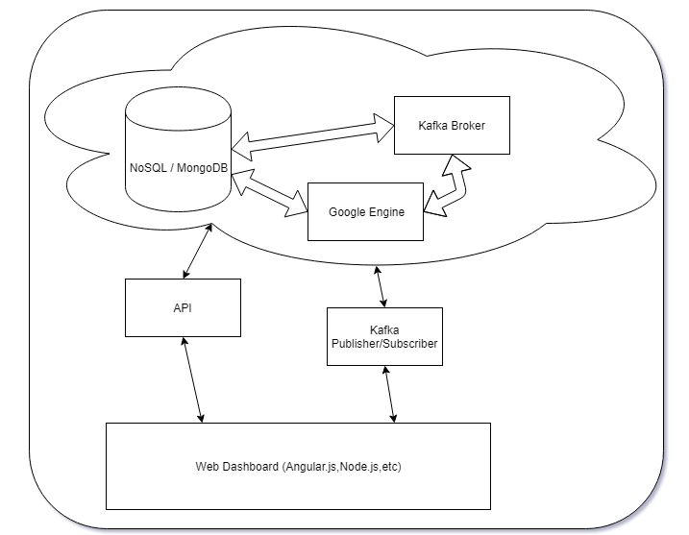

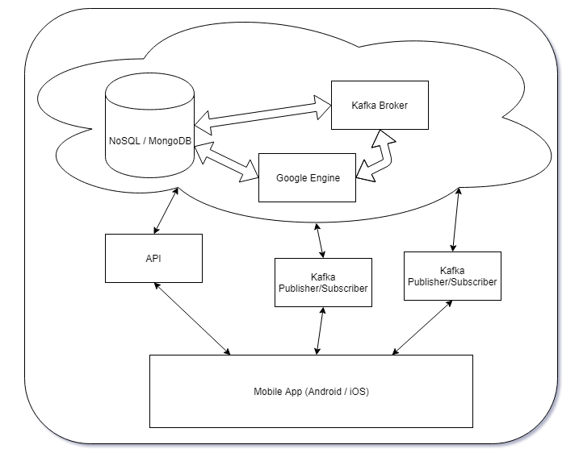

#### APIs Architecture

### APIs Specifications

#### APIs Framework/Tools

* RESTful CRUD
* NodeJS/ExpressJS
* Joi - Validation
* Swagger
* POSTMAN
* Cassandra (NoSQL DB)
* JSON
* BitBucket
* draw.io

#### Things to consider

* Country (Every country will have different credit cards database)
* APIs to be called by
  + mobile apps
  + web apps
  + partners 3rd party app
* Kafka Broker
* Caching
* Response Time
* Partner Access
* Token/OAUTH2.0 Authentication
* Postman/Swagger Testing Automation
* API Server
* Server Ports
* Load Balancer
* Cloud Hosting (AWS/Azure/Google Cloud)
* APIs Analytic
  + Monitoring APIs usage, threshold, traffic, users, timeline, location

Following are the different categories of APIs that need to be designed and implemented:

#### 

#### 

#### 

#### i) Authentication API

CREATE

* NA

RETRIEVE

* getToken

UPDATE

* NA

DELETE

-NA

#### My Cards APIs

CREATE

* NA

RETRIEVE

* *getMyCards*

UPDATE

* NA

DELETE

-NA

#### Card2Use APIs

CREATE

* NA

RETRIEVE

* + *getBestCardToUse*

UPDATE

* NA

DELETE

-NA

#### iv. Card2Use Monitor (Admin Usage, to be used by Card2Use internal)

CREATE

* NA

RETRIEVE

* + *getReportOnLocation*
  + *getReportOnCardType*
  + *getReportOnBusinessType*
  + *getReportOnBankType*
  + *getMostPopulerCard*
  + *getUsersList/country/*

UPDATE

* NA

DELETE

-NA

#### Login API

CREATE

* NA

RETRIEVE

* + *getLogedin*

UPDATE

* NA

DELETE

-NA

#### Wallet Configuration APIs

CREATE

* + *postCardToWallet*

RETRIEVE

* + NA

UPDATE

* NA

DELETE

-NA

#### Registration API

CREATE

* + NA

RETRIEVE

* + NA

UPDATE

* *putUpdateInfo*

DELETE

-NA

#### My Offers

#### CREATE

* + NA

RETRIEVE

* + *getMyOffers*

UPDATE

* NA

DELETE

-NA

#### User Profile

#### CREATE

* + NA

RETRIEVE

* + *getMyProfile*

UPDATE

* NA

DELETE

-NA

**xi. Delete Card**

#### CREATE

* + NA

RETRIEVE

* + NA

UPDATE

* NA

DELETE

- deleteCard

**xii. List of most used card based on location**

#### CREATE

* + NA

RETRIEVE

* + getMostUsedCard

UPDATE

* NA

DELETE

- NA

**xiii. Add bank based on location for admin**

#### CREATE

* + postBank

RETRIEVE

* + NA

UPDATE

* NA

DELETE

- NA

**xiv. Add card types with bank and location by Admin**

#### CREATE

* + postCardTypes

RETRIEVE

* + NA

UPDATE

* NA

DELETE

- NA

**xv. List of banks based on location**

#### CREATE

* + NA

RETRIEVE

* + getBankList

UPDATE

* NA

DELETE

- NA

**xvi. List of banks based on location**

#### CREATE

* + NA

RETRIEVE

* + getBankList

UPDATE

* NA

DELETE

- NA

**xvii. Post card benifits from admin**

#### CREATE

* + postCardBenifits

RETRIEVE

* + NA

UPDATE

* NA

DELETE

- NA

**xviii. List of banks based on location**

#### CREATE

* + NA

RETRIEVE

* + getBankList

UPDATE

* NA

DELETE

- NA

**xix. List of cards based on location and bank**

#### CREATE

* + NA

RETRIEVE

* + getAllCardList

UPDATE

* NA

DELETE

- NA

**xx. Add missing cards**

#### CREATE

* + postMyCard

RETRIEVE

* + NA

UPDATE

* NA

DELETE

- NA

**xxi. Add Review**

#### CREATE

* + postReview

RETRIEVE

* + NA

UPDATE

* NA

DELETE

- NA

**xxii. List review for admin**

#### CREATE

* + NA

RETRIEVE

* + getReviewList

UPDATE

* NA

DELETE

- NA

**xxiii. Contact us**

#### CREATE

* + postContactRequest

RETRIEVE

* + NA

UPDATE

* NA

DELETE

- NA

**xxiv. List contact request for admin**

#### CREATE

* + NA

RETRIEVE

* + getContactRequestList

UPDATE

* NA

DELETE

- NA

**xxv. Add FAQ for admin**

#### CREATE

* + postFAQ

RETRIEVE

* + NA

UPDATE

* NA

DELETE

- NA

**xxvi. List FAQ**

#### CREATE

* + NA

RETRIEVE

* + getFAQ

UPDATE

* NA

DELETE

- NA

**xxvii. Edit FAQ for admin**

#### CREATE

* + NA

RETRIEVE

* + NA

UPDATE

* putFAQ

DELETE

- NA

**xxviii. Delete FAQ for admin**

#### CREATE

* + NA

RETRIEVE

* + NA

UPDATE

* NA

DELETE

- deleteFAQ

**NB :**

**Common Error Code for All API :**

#### 400 (Bad Request)

#### 401 (Unauthorized)

#### 403 (Forbidden)

#### 404 (Not Found)

#### 405 (Method Not Allowed)

#### 500 (Internal Server Error)

**Common Success code for all API**

200(OK)

### Design

This section provides High Level Design of each components of the API solutions. Architecture section will have the diagram and this section will have extension of Architecture in detail.

#### 

#### 

### Development and Testing Strategy

### Project Schedule

**APIs Specifications and Design**

**Card2Use**

*Website: www.*Card2Use*.com*

*Mobile App:* Card2Use